We have done a bit of research and thought a bit more about our concept for DECO3500 yesterday afternoon and this morning. We would really like to nail down a core concept so we can make as much progress as possible, so any feedback would be great!

We have decided to focus on social isolation in the elderly as well as digital literacy and our research has highlighted that 50 to 60 percent of Australians living residentially suffer from loneliness due to living by themselves or not having much social interaction. We also found that a key intervention to reducing loneliness for the elderly includes developing community networks, which is what we were thinking of doing with our concept. We believe that this could be a core motivator in getting the elderly to engage in a digital news medium.

We have decided that to ensure our application embodies a community focus we will create a “bulletin” type of board where the users can pin stories they find interesting to. They would also be able to see stories their friends have pinned. The red represents the stories they’ve pinned and the blue represents the stories from other community members.

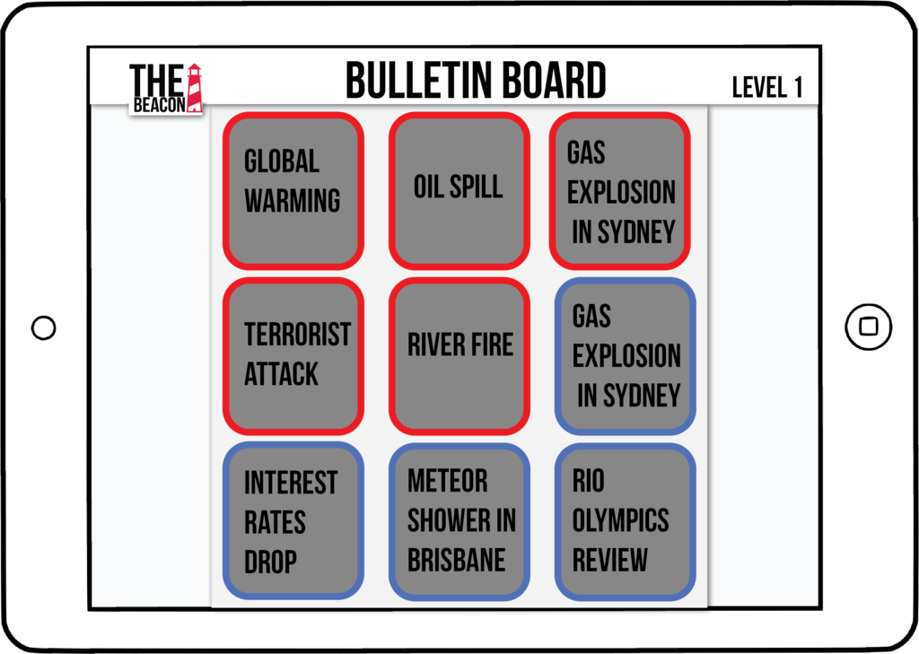

One of the sources we found also mentioned that the most effective intervention in reducing loneliness was utilising existing community resources to make the elderly feel more comfortable and in this case that would be the bulletin board.This would also incorporate elements of emotional design.

Please let us know your thoughts.

Thanks,

Team Fruity Tutti

Prac 2, Friday 10AM - 12PM

Team members: Grace, Zoe, Jonas, Theo

* How to get elderly online
* Elderly people have difficulty learning new tools and like to stick with what they know. Learning becomes “optional” later in life and therefore elderly people lose the motivation to learn. This is why they have difficulty learning new technologies. <http://www.embracepossibility.com/blog/why-old-people-have-a-hard-time-learning-new-things/>

Research on Social Isolation & Loneliness amongst Older people:

<http://www.publish.csiro.au/AH/pdf/AH080468>

* “It is clearly important that older people have access to service and supports that help them maintain their social connections”.
* Many elderly Australians are lonely ie. a person’s perception of their level of social engagement is deficient in terms of quality & quantity. They may feel this way because they don’t have easy access to community groups, are living alone, have been widowed or even if they just believe that there’s no one around them.
* 50 to 60 percent of Australian elders (living residentially) suffer from loneliness or indicate that they feel lonely
* Levels of loneliness also deepen depending on the time of day, it was found that people are more lonely in the evenings
* Interventions to reduce loneliness in elderly people include group based activities, home visits and notably, **developing community networks** such as social clubs,
* The most effective interventions were a combination of strategies:
  + involving older people and/or their representative groups in intervention planning and implementation
  + **utilising existing community resources** (we could argue this is the bulletin board); and targeting specific groups
* “There is a need to develop strategies that can help to reduce or eliminate the causes of isolation or loneliness, to the extent this is possible, and to build on those factors that are known to be protective.”

Journalistic problem space ideas:

* Sensationalism: newspapers tend to play up & dwell on stories that are sensational (eg. murder, car crash, kidnapping etc),

<http://www.anxietycanada.ca/english/pdf/ElderlyEn.pdf>”

between 5.5 and 10% of seniors are suffering from an anxiety disorder”. These “sensationalism” news stories may cause them to overthink etc and frighten them. Therefore our app will be localised(?)